1. Write a Java code to print the array as a zigzag array.

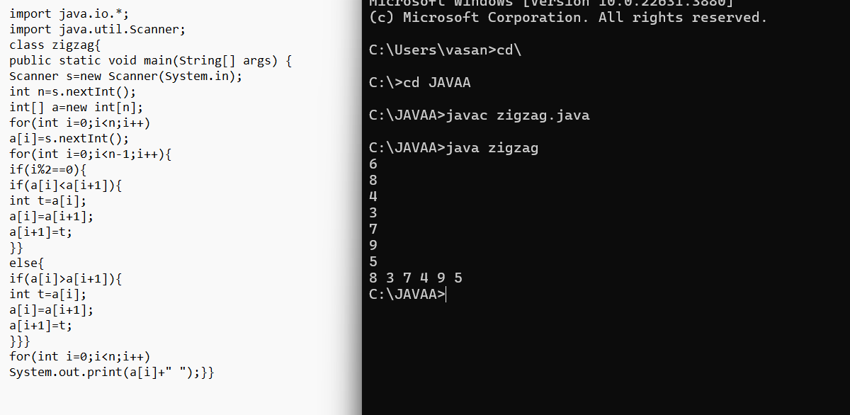

1. Write a Java code for a given array of integers to find a peak element. A peak element is an element an integer is a neighbor.

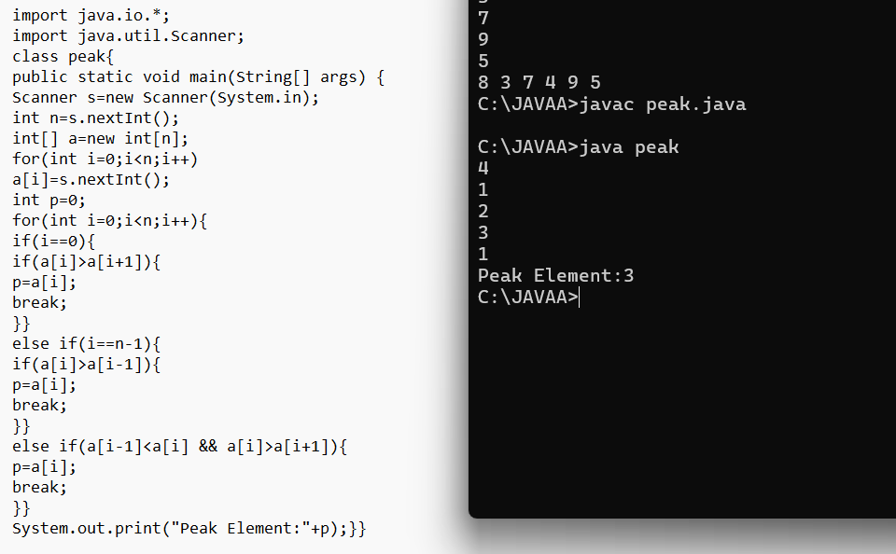

1. Given a string s consisting of words and spaces, return the length of the last word in the string. A word is a maximal substring consisting of non-space characters only. There will be at least one word, consists of only English letters and spaces ' '. Example 1: Input: s = "Hello World" Output: 5 Explanation: The last word is "World" with length 5.

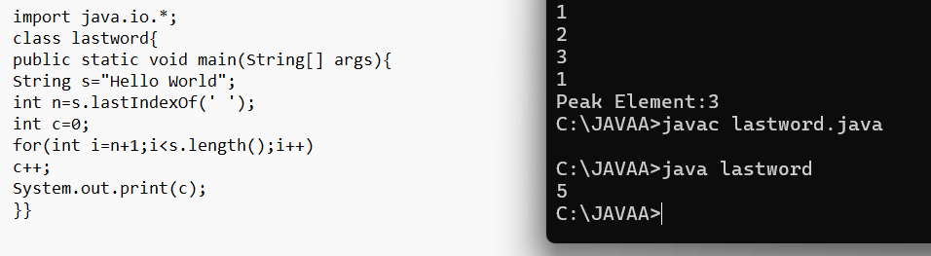

1. Write a java code to find the contiguous subarray with an array which is the largest sub.

